Question 1:
Create a dictionary of five books and their authors. Print the author for each book.
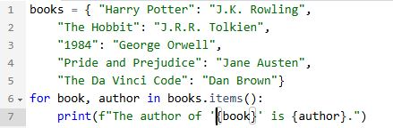
Output:
